Ethan Allen Mum blue Sofa

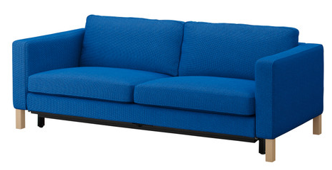

|  |
| --- |
| **DESCRIPTION** |
| Mum blue Sofa produced by Ethan Allen Co, presents a blue diamond comfortable sofa. The hollow cushion relaxes the spinal cord extra long legs on bottom make it easy to clean under the sofa. Air tight and spring form works together to maintain sofa to keep the shape together and double coding lifts the sofa. |

|  |  |  |
| --- | --- | --- |
| **Price** | **3500$** | |
| **Dimensions** | **H** x **W** x **L** | **35in x 32in x 64in** |
| **Features** | **After a back aching day you can relax and fix your back and enjoy our comfort level.** | |
| **Finished** | **Netted Hollow Back** | |
| **Available in** | **Blue and Green** | |